Lab 11 Design and Analysis of Algorithms

Name: Tanvi Penumudy

Enroll No: E18CSE187

Batch: EB06

**Implementation of Dijsktra’s Algorithm for Shortest Path**

**Question:**

Consider the problem of shortest path between two vertices, source (S) and destination T, in a given weighted graph G = (V,E). You all know that one can ﬁnd a shortest path between S and T in graph G in O(|E|log|V|)-time by Dijkstra’s algorithm. In this lab you are expected to implement the Dijkstra’s algorithm and test your algorithm for the following graph with source S = 0 and destination T = 4.

**Given Undirected Graph:**

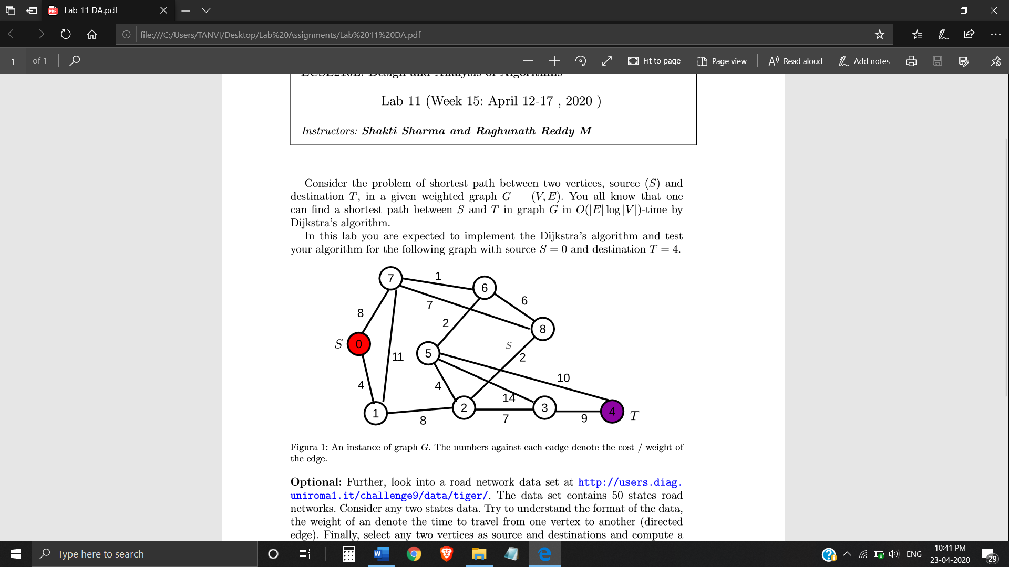

Fig1: An instance of graph G. The numbers against each edge denote the cost/weight of the edge.

**Adjacency Matrix for Weighted Undirected Graph:**

|  |  |  |  |  |  |  |  |  |  |
| --- | --- | --- | --- | --- | --- | --- | --- | --- | --- |
| **V** | **0** | **1** | **2** | **3** | **4** | **5** | **6** | **7** | **8** |
| **0** | 0 | 4 | 0 | 0 | 0 | 0 | 0 | 8 | 0 |
| **1** | 4 | 0 | 8 | 0 | 0 | 0 | 0 | 11 | 0 |
| **2** | 0 | 8 | 0 | 7 | 0 | 4 | 0 | 0 | 2 |
| **3** | 0 | 0 | 7 | 0 | 9 | 14 | 0 | 0 | 0 |
| **4** | 0 | 0 | 0 | 9 | 0 | 10 | 0 | 0 | 0 |
| **5** | 0 | 0 | 4 | 14 | 10 | 0 | 2 | 0 | 0 |
| **6** | 0 | 0 | 0 | 0 | 0 | 2 | 0 | 1 | 6 |
| **7** | 8 | 11 | 0 | 0 | 0 | 0 | 1 | 0 | 7 |
| **8** | 0 | 0 | 2 | 0 | 0 | 0 | 6 | 7 | 0 |

**Implementation:**

(Code on the Notepad)

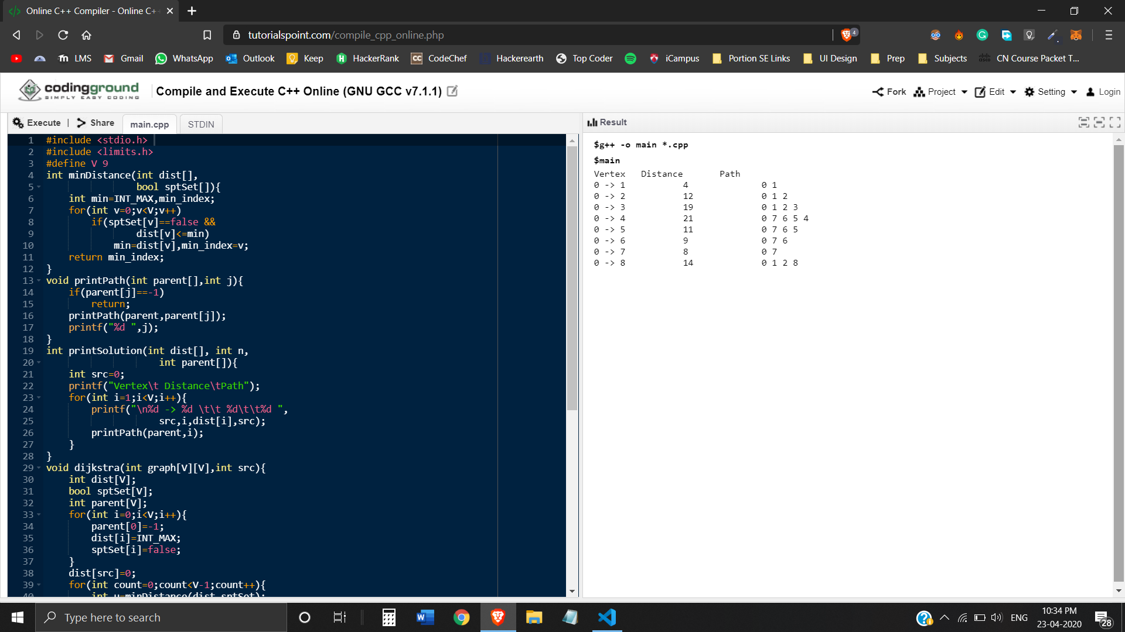 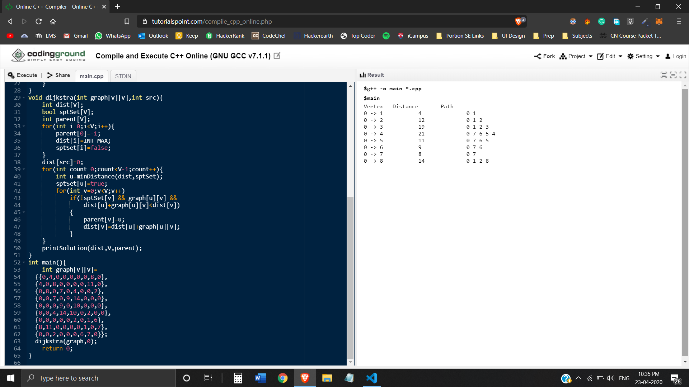

**Output:** The shortest Distance and Path with source S = 0 and destination T = 4 in the given graph. In orange

